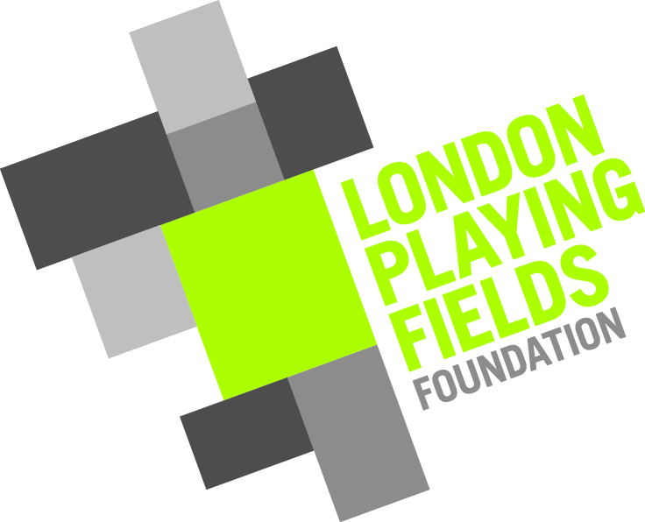
London Playing Fields Foundation
COVID-19 Risk Assessment and Operational Procedures checklist - Cricket

LPFF Ground | TBC
Hiring Group | Cricket team
Activity | Cricket match
Hiring group documentation | TBC

Outdoor area(s) in use | Cricket pitch
Indoor area(s) in use | Toilet within (TBC)

Description of activity | Cricket match

People Management and Communication
 | Screening of staff before they arrive at the venue to ensure individuals displaying COVID-19 symptoms or those who should be shielding do not travel or attend. | Explicit verbal or written confirmation from each staff member that they and all persons in their household/bubble have had none of the prescribed symptoms of COVID-19 for the last 7/14 days.  - High temperature  - New persistent cough  - Loss or change to sense of smell or taste
 | Staff allocation | One member of Supervision staff
 | Assess user numbers, space capacities, venue circulation and layout planning to maintain social distancing. | External capacity: to meet ECB guidelines  Internal capacity: “1 in 1 out” system for use of toilet
 | Signage to make all users are aware of the control measures in place and how to act appropriately to minimise the risk of transmission of COVID-19. | Signage:  Site specific signs manufactured and installed

Hygiene and Cleaning
 | Provision of hand washing facilities with warm water, soap, disposable towels and bin. | Facilities to be available in toilet area.  Check every hour and re-stock and remove rubbish as necessary.
 | Provision of suitable hand sanitiser in locations around the facility to maintain frequent hand sanitisation. | Sanitiser at entrance to and exit from building
 | Cleaning strategy to minimise risk of COVID-19 transmission. | All surfaces in areas to be used to be cleaned before and after each session.
 | High-frequency touchpoint cleaning strategy to minimise COVID-19 transmission risk. | High-frequency touch points to be cleaned at hourly intervals during each session:  - Handles of entrance door and internal doors on route to toilet  - Toilet door handle  - Toilet flush  - Basin and taps  - Soap and sanitizer dispensers
 | Ensure cleaning materials and PPE is on site to allow for effective protection and cleaning. | Materials to be kept at pre-determined stock levels.  Order turn around time of 48 hours

Buildings and equipment
 | Assess the maximum occupancy of external and internal areas in use to maintain current social distancing guidance. Establish a suitable circulation system/one-way system if necessary. Signage/floor markings to be used to communicate this as necessary. | External: ECB guidleines  Internal: Maximum capacity of toilet is 1
 | Condition of playing surfaces | Strips, squares and outfields to be prepared in accordance with LPFF normal practice.
 | Non-personal equipment belonging to LPFF to be cleaned before and after each session. | (list items, if any to be cleaned)

